**Calculator Bugs**

1. Numbers addition bug: The result of addition of numbers is subtracted by 2.

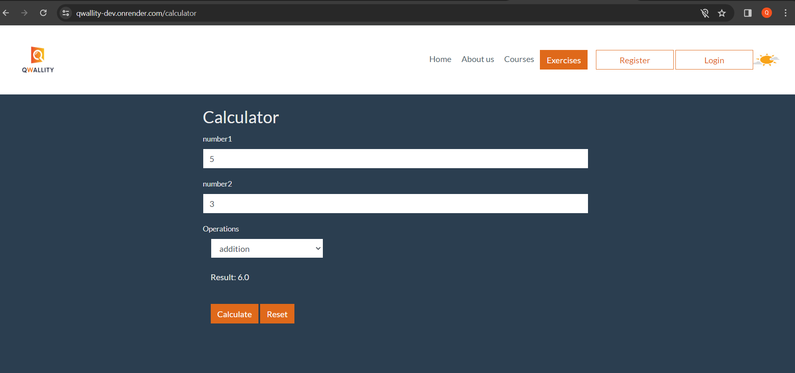

1. Calculator reset bug: When we reset the calculator, only Result and Operations reset, Number 1 and 2 remain filled.

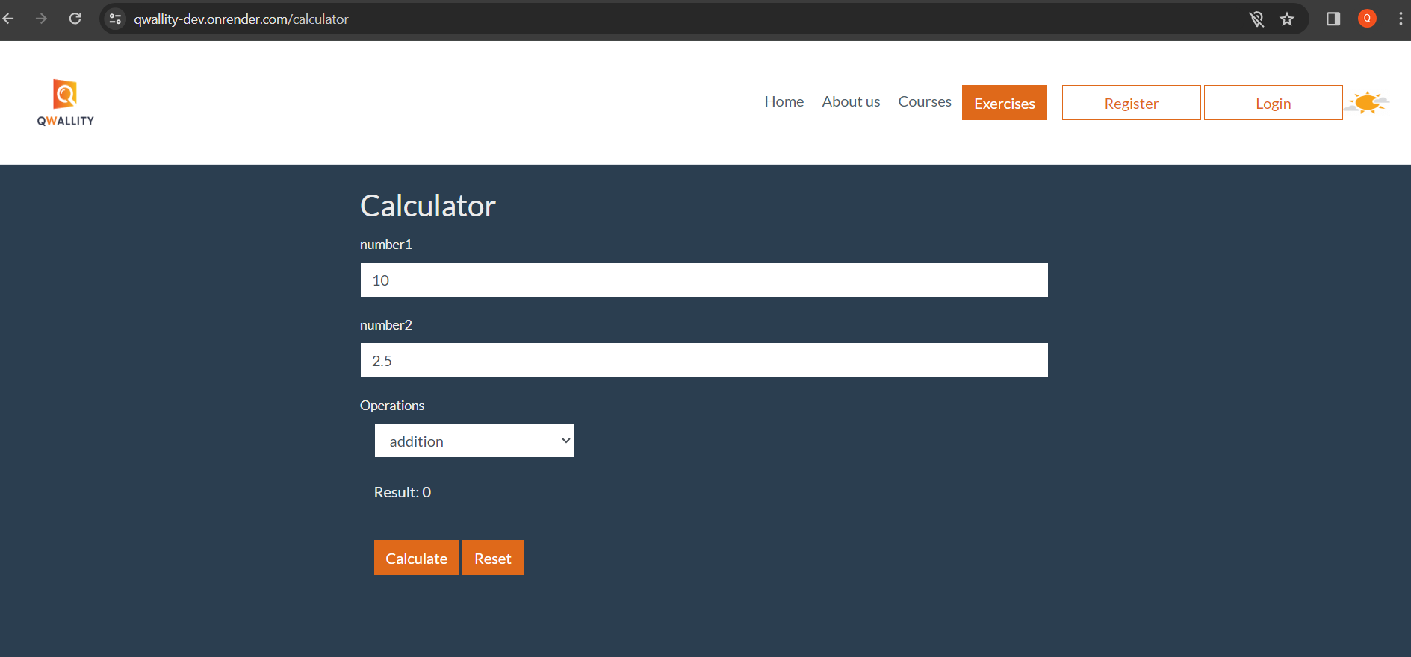

1. You can add zero before the number, and it remains.

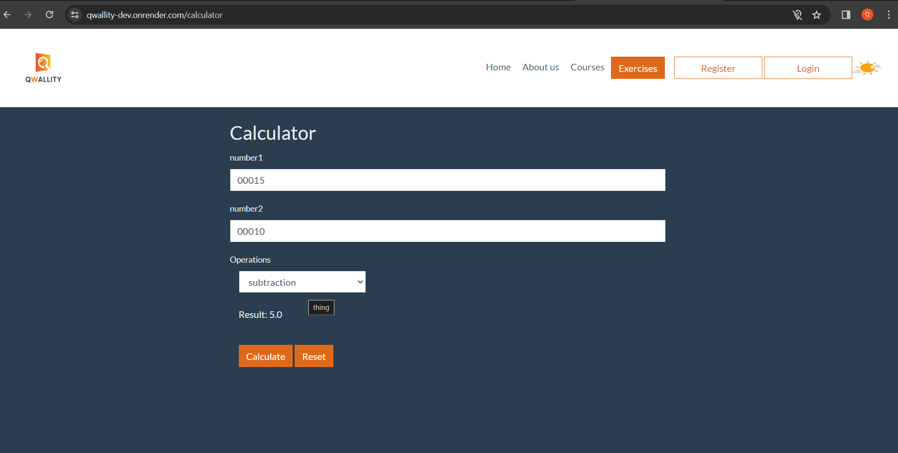

1. Number rounding bugs:

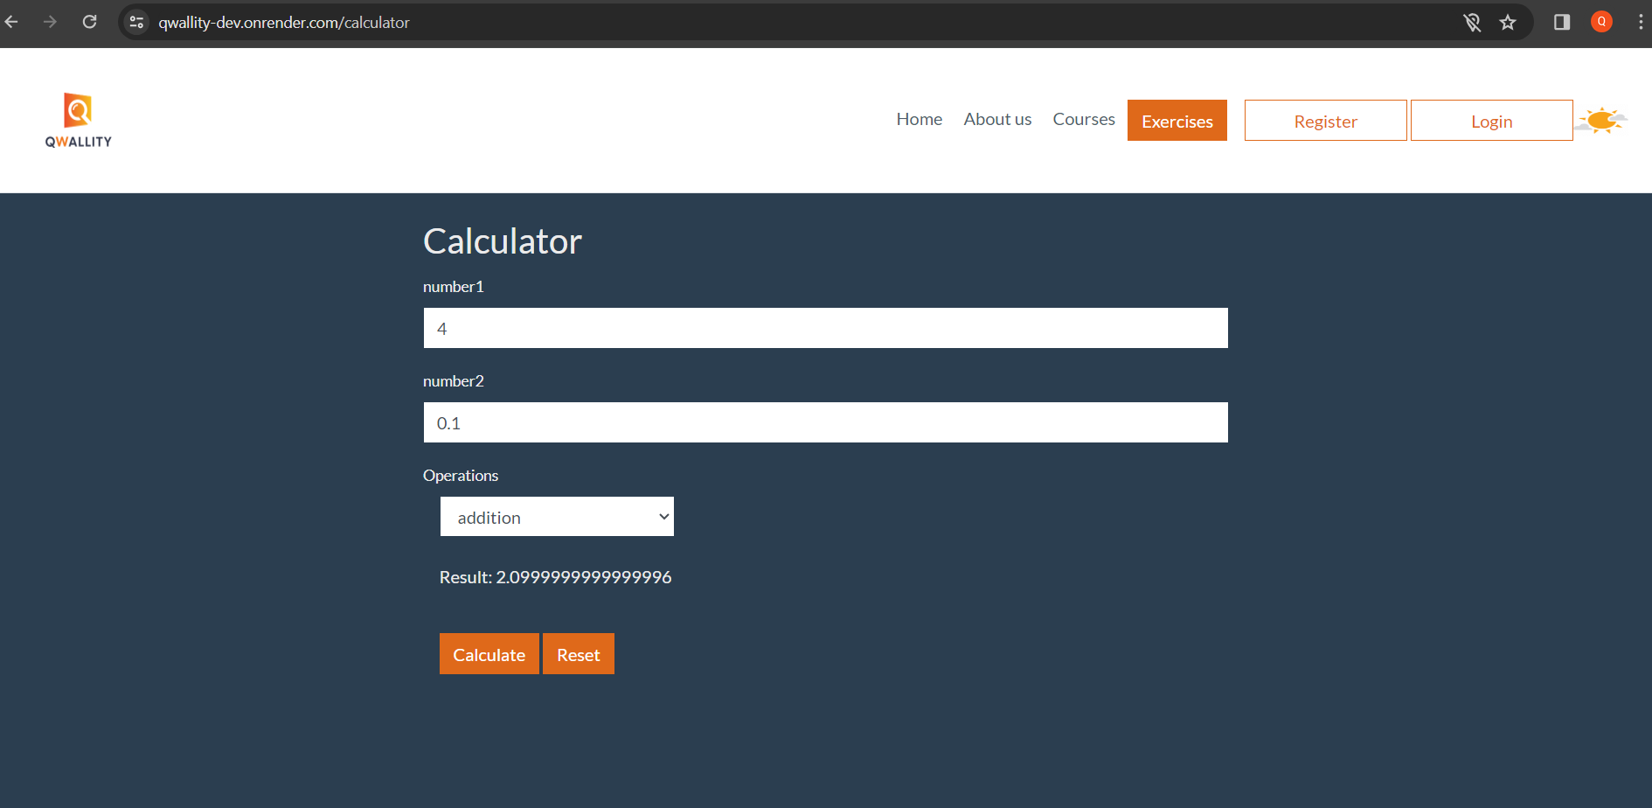

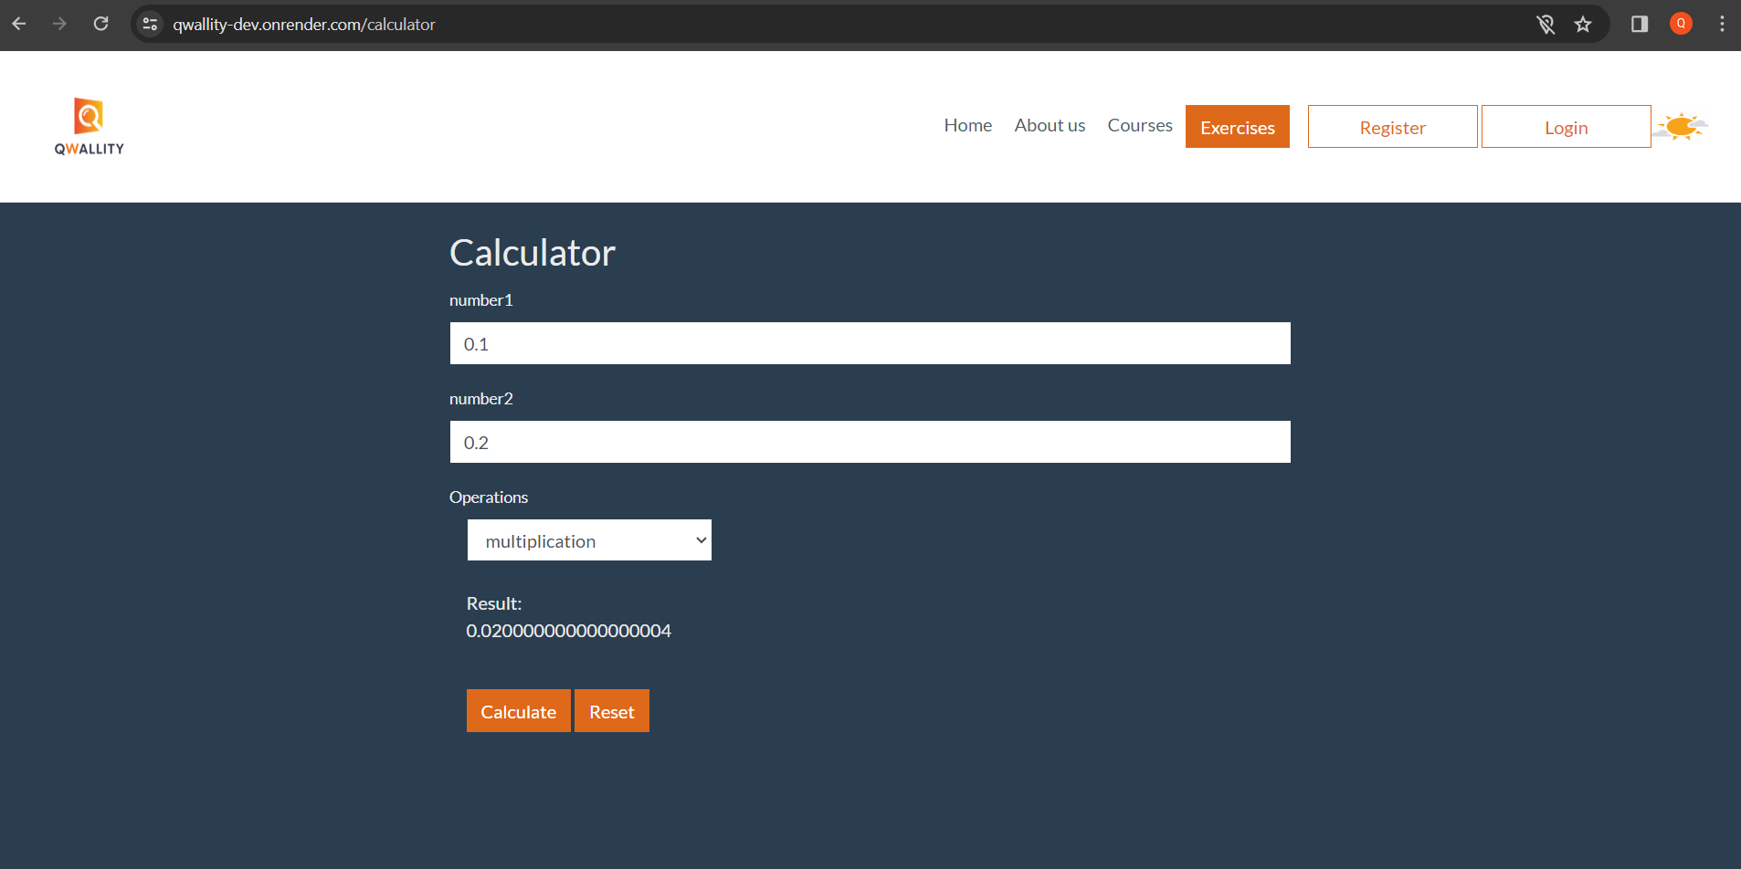

1. Wrong number input: The calculator allows to put a dot before number.

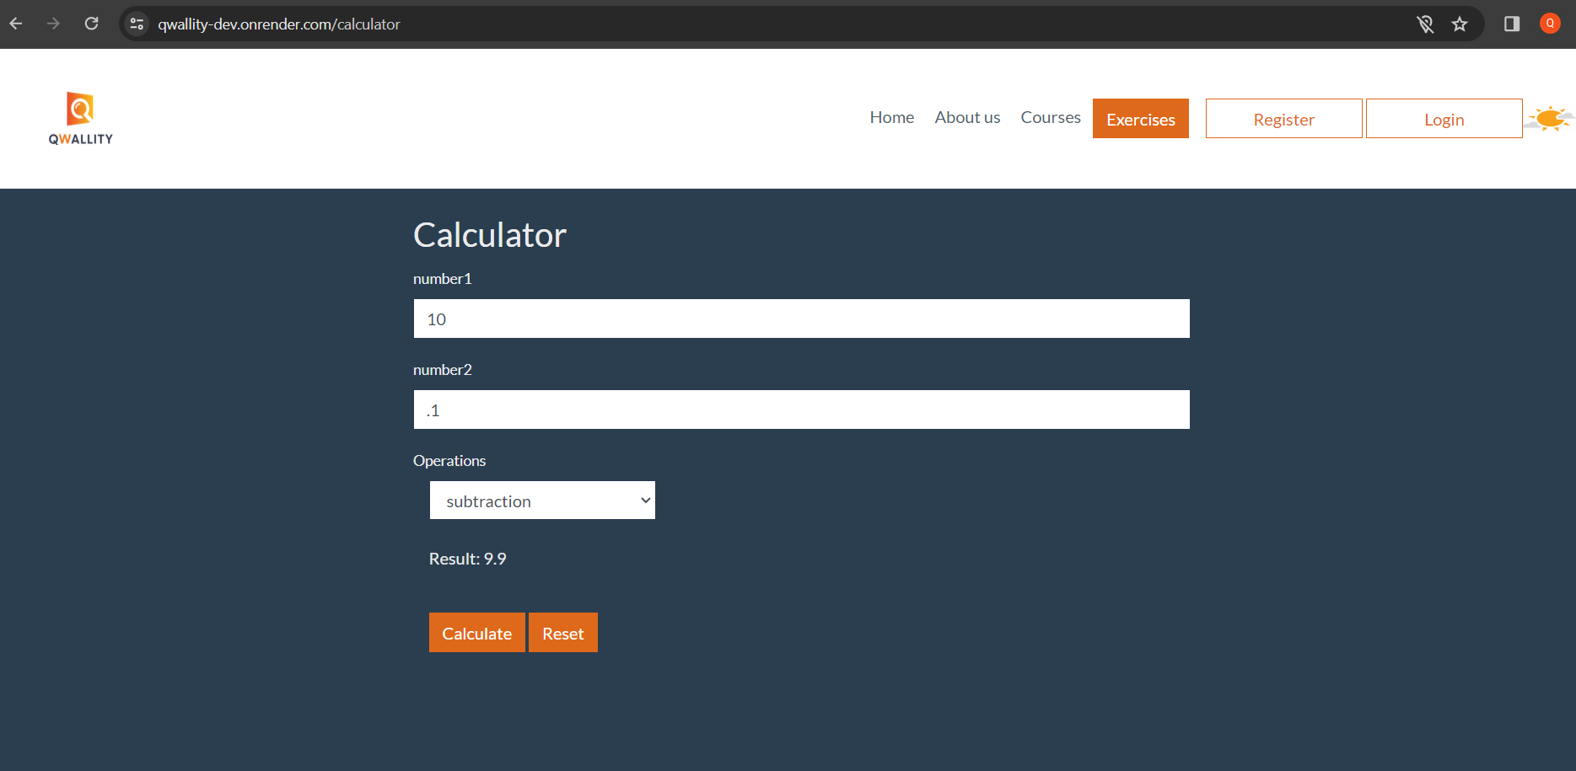

1. I can put -0.

